
SMART ELECTRICAL LOAD BALANCING
USING MINIMUM SPANNING TIME

A CAPSTONE PROJECT REPORT

A Capstone Project Report submitted in partial fulfilment of the requirements for the Course of

CSA0603 & Design and Analysis of Algorithm

to the award of the degree of

BACHELOR OF TECHNOLOGY
IN
B.TECH AIML

Submitted by
KUMARAN M (192525022)

Under the Supervision of

Dr.P.Solainayagi

SIMATS ENGINEERING
Saveetha Institute of Medical and Technical Sciences
Chennai-602105

SEPTEMBER 2026

BONAFIDE CERTIFICATE

This is to certify that the Capstone Project entitled “ SMART ELECTRICAL LOAD BALANCING USING MINIMUM SPANNING TREE” has been carried out by KUMARAN M (192525022)under the supervision of Dr.P.Solainayagi and is submitted in partial fulfilment of the requirements for the current semester of the B.TECH AIML program at Saveetha Institute of Medical and Technical Sciences, Chennai.

COURSE COORDINATOR COURSE FACULTY

Title / Name, Dr.P.Solainayagi

Designation Designation

Department Name Department Name SIMATS Engineering, SIMATS Engineering,
SIMATS, Chennai – 602105. SIMATS, Chennai – 602105.

DECLARATION

We, KUMARAN M of the B.TECH AIML , SIMATS Engineering, Saveetha Institute of Medical and Technical Sciences, Chennai, hereby declare that the Capstone Project Work entitled “SMART ELECTRICAL LOAD BALANCING USING MINIMUM SPANNING TREE” is the result of our own Bonafide efforts. To the best of our knowledge, the work presented herein is original, accurate, and has been carried out in accordance with the principles of engineering ethics and academic integrity. All sources, references, data, and other materials used in the project have been appropriately acknowledged. We further declare that the data, results, analysis, and findings presented in this report have not been fabricated, falsified, or manipulated. Any external tools, software, datasets, computational resources, or AI-assisted tools used during the project have been appropriately disclosed. We confirm that all applicable ethical, academic, institutional, and professional requirements have been duly followed throughout the planning, execution, analysis, and documentation of the project.

Place: CHENNAI
Date:

Signature of the Students with Names

Individual Contribution Statement

Student  Name /  Register No. | Specific Responsibilities | Design &  Development Contribution | Testing &  Analysis  Contribution | Report Contribution | Approx.  Contribution  (%)
192525022 | Network creation and graph modelling | Network design and implementation | Connectivity and test-case analysis | Chapters 1–4 and Appendix A | 100%
Total |  |  |  |  | 100%

ABSTRACT
Smart electrical load balancing requires an efficient representation of interconnected electrical distribution points and their possible connections. In the proposed project, SMART ELECTRICAL LOAD BALANCING USING MINIMUM SPANNING TREE, the electrical distribution system is represented as a weighted graph. Electrical loads or distribution points are modelled as nodes, while possible electrical connections are represented as weighted edges. The edge weight can represent a selected connection parameter such as transmission cost, distance, resistance, or a power-loss-related value.
Module 1, Network Creation, focuses on developing the initial weighted electrical network that serves as the foundation for the later optimization stages. The module defines the electrical nodes, establishes possible connections, assigns weights, creates the graph structure, verifies network connectivity, and provides a graphical representation of the network.
The developed network model provides structured input for the MST module, where an efficient spanning structure can be identified using an algorithm such as Kruskal’s or Prim’s algorithm. The modular design separates network generation from optimization and reporting, making the system easier to test, modify, and extend.
Keywords: Electrical Load Balancing, Minimum Spanning Tree, Weighted Graph, Network Creation, Graph Theory, Power Distribution

TABLE OF CONTENTS
Chapter No. | Title / Section | Page No.
1 | CHAPTER 1: Introduction and Engineering Problem | 11
1.1 | Background | 11
1.2 | Need for the Project | 12
1.3 | Problem Statement | 12
1.4 | Project Aim | 12
1.5 | Project Objectives | 13
1.6 | Scope | 13
1.7 | Expected Engineering Outcome | 13
2 | CHAPTER 2: Literature Review and Existing Solutions | 14
2.1 | Review Method | 14
2.2 | Review of Existing Work | 14
2.3 | Comparative Analysis | 14
2.4 | Research / Engineering Gap | 15
2.5 | Proposed Contribution | 15
3 | CHAPTER 3: Engineering Design & Trade-offs, Sustainability, Ethics, Safety, Risk & Security | 16
3.1 | Requirements | 16
3.2 | Constraints & Applicable Standards | 17
3.3 | Design Specifications | 17
3.4 | Alternative Solutions & Evaluation | 18
3.5 | Selected Design & Detailed Design | 18
3.6 | Trade-off Analysis | 19
3.7 | Sustainability, Ethics, Safety, Risk & Security | 19
4 | CHAPTER 4: Implementation, Testing & Results, Project Management | 21
4.1 | Development Approach & Resources | 21
4.2 | Software Implementation & Modern Tools Used | 21
4.3 | Test Plan & Verification | 23
4.4 | Results | 24
4.5 | Data Analysis & Engineering Judgment | 24
4.6 | Comparison with Existing Solutions & Achievement of Objectives | 24
4.7 | Strengths & Limitations | 26
4.8 | Project Planning, Roles & Budget | 26
5 | CHAPTER 5: Conclusion, Future Work and Reflection | 27
5.1 | Conclusion | 27
5.2 | Future Work | 27
5.3 | Professional Learning & Individual Reflection | 27-28
— | References | 29
— | Appendices | 30

LIST OF FIGURES
Figure No. | Figure Name | Page No.
Fig:1 | Generate MST | 22
Fig:2 | Check Loads | 22

LIST OF TABLES
Table No. | Table Name | Page No.
Table 3.1 | Functional and Non-Functional Requirements | 16
Table 3.2 | Design Specifications | 17
Table 3.3 | Alternative Solution Evaluation | 17
Table 3.4 | Risk Register | 18
Table 4.1 | Software and Resources | 21
Table 4.2 | Test Plan | 21
Table 4.3 | Objective Achievement | 22

LIST OF ABBREVIATIONS / SYMBOLS
Symbol | Description | Unit
MST | Minimum Spanning Tree | —
N | Electrical/Distribution Node | Node
E | Network Edge / Connection | Connection
W | Edge Weight | Weight
TC | Test Case | —

CHAPTER 1

INTRODUCTION AND ENGINEERING PROBLEM

1.1 Background
Electrical power distribution networks consist of multiple generating sources, distribution nodes, transmission paths, and electrical loads. Efficient management of these interconnected components is important to maintain reliable power distribution and reduce unnecessary transmission losses. When electrical loads are unevenly distributed across a network, some paths may become highly loaded while other available paths remain underutilized.
The proposed project represents the electrical distribution system as a weighted network. Nodes represent electrical buses, distribution points, or loads, while edges represent possible electrical connections. Edge weight represents a selected parameter such as transmission cost, distance, resistance, or power-loss-related value.
In Module 1 – Network Creation, the objective is to create a suitable electrical network model that can be processed by the subsequent Minimum Spanning Tree algorithm.

1.2 Need for the Project
• Electrical loads may not be distributed efficiently across available connections.
• Redundant network connections can increase transmission cost and complexity.
• Manual identification of an efficient network structure is difficult for larger systems.
• A mathematical graph representation allows electrical connections to be analysed systematically.
• An MST can identify a connected network with minimum total edge weight.
• The network model provides a foundation for further load-balancing analysis.
The engineering significance of Module 1 is that it converts the electrical distribution problem into a weighted graph problem, making it suitable for algorithmic optimization.

1.3 Problem Statement
To design and develop a weighted electrical network model in which electrical distribution points are represented as nodes and their possible interconnections are represented as weighted edges, so that the created network can subsequently be analysed using a Minimum Spanning Tree approach for efficient electrical load balancing.
• Multiple electrical nodes.
• Multiple possible interconnections.
• Different edge weights.
• Network connectivity.
• Avoidance of unnecessary connections.
• Compatibility with the subsequent MST-based optimization module.

1.4 Project Aim
The aim of this module is to create a connected weighted electrical network that represents the relationships between electrical loads and distribution points and provides the input structure for Minimum Spanning Tree-based load balancing.

1.5 Project Objectives
1. To identify the electrical nodes required for the network model.
2. To establish possible connections between the electrical nodes.
3. To assign suitable weights to the network connections.
4. To represent the electrical distribution system as a weighted graph.
5. To verify that the generated graph is connected.
6. To provide the generated network as input to the MST module.
7. To create a simple and scalable network structure for further analysis.

1.6 Scope
Included: creation of electrical network nodes; creation of connections; assignment of weights; weighted graph representation; connectivity verification; graph visualization; and preparation of input for the MST algorithm.
Excluded: real-time control of electrical equipment; physical switching of electrical circuits; direct measurement of current or voltage; hardware-based power distribution control; and protection relay implementation.
Assumptions: each electrical distribution point is represented as a graph node; every valid connection is represented by an edge; edge weights are predefined or calculated from selected network parameters; and the network is assumed to be connected before MST processing.
Boundary conditions: the module operates at the network-model level and does not directly control physical electrical equipment.

1.7 Expected Engineering Outcome
The expected outcome of Module 1 is a weighted electrical network graph containing electrical nodes, possible connections, connection weights, a connected graph structure, graph visualization, and network data suitable for the Minimum Spanning Tree algorithm. The output becomes the input to Module 2 – MST Graph Generation.

CHAPTER 2

LITERATURE REVIEW AND EXISTING SOLUTIONS

2.1 Review Method
The network creation approach is based on concepts from graph theory, electrical distribution networks, network optimization, and Minimum Spanning Tree algorithms. Existing approaches for representing interconnected systems were considered to identify an appropriate mathematical model for the proposed project.

2.2 Review of Existing Work
Traditional electrical distribution networks generally contain multiple interconnected nodes and paths. Graph theory provides a convenient method for representing such systems computationally. A graph consists of vertices and edges. In the proposed system, vertices represent electrical distribution points, while edges represent possible connections. By assigning weights to edges, different connection costs or electrical parameters can be represented.
Minimum Spanning Tree techniques such as Kruskal’s algorithm and Prim’s algorithm can subsequently be applied to weighted connected graphs to determine a minimum-cost spanning structure. Graph-based modelling is selected because it provides a simple computational representation of the electrical network and allows the network structure to be optimized in later modules.

2.3 Comparative Analysis
Existing Approach | Advantages | Limitations | Relevance to Proposed Work
Manual Network Design | Simple for small networks | Difficult for large networks | Basic network concept
Full Graph Representation | Represents all possible connections | May contain redundant connections | Initial network
Adjacency Matrix | Easy computational representation | More memory for large networks | Network storage
Adjacency List | Memory efficient for sparse networks | Slightly more complex | Graph implementation
MST-Based Network | Reduces total connection weight | Does not independently represent all electrical constraints | Optimization

2.4 Research / Engineering Gap
Existing electrical network representations can contain numerous possible connections. Simply representing all connections does not identify which connections are most efficient. The engineering gap addressed by the proposed system is the development of a structured network representation that can be directly processed by an MST algorithm to obtain an optimized network structure.

2.5 Proposed Contribution
The proposed Module 1 contributes a weighted graph-based electrical network creation method. It provides a systematic representation of electrical nodes and their connections and prepares the network for MST-based optimization. The overall modular flow is Network Creation → MST Optimization → Load Balancing → System Report.

CHAPTER 3

ENGINEERING DESIGN & TRADE-OFFS, SUSTAINABILITY, ETHICS, SAFETY, RISK & SECURITY

3.1 Requirements
Stakeholder | Requirement
System Developer | Simple and reliable network creation
System User | Clear visualization of the electrical network
Project Evaluator | Correct graph representation
Optimization Module | Connected weighted graph as input
Maintenance/User | Easy modification of nodes and connections

Requirement | Type | Measurable Target
Create electrical nodes | Functional | All specified nodes generated
Create connections | Functional | Valid edges generated
Assign edge weights | Functional | Weight assigned to every edge
Verify connectivity | Functional | Graph must be connected
Display network | Functional | Graph visualization generated
Processing efficiency | Non-Functional | Suitable for project-scale networks
Reliability | Non-Functional | Consistent graph generation

3.2 Constraints & Applicable Standards
Constraint / Standard | Requirement | Application
Computational constraint | Efficient graph processing | Lightweight graph representation
Electrical safety | Avoid direct physical intervention | Software-based modelling
Data integrity | Correct node and edge information | Input validation
Engineering ethics | Accurate reporting | Results are not fabricated

Since Module 1 is a software-based network model, physical electrical standards are not directly implemented in this module. Any electrical standards applicable to a future physical implementation would need to be addressed separately.

3.3 Design Specifications
Parameter | Target / Requirement | Unit | Priority
Number of nodes | User-defined | Nodes | High
Number of edges | User-defined | Connections | High
Edge weight | Positive numerical value | Weight | High
Network connectivity | Fully connected | Boolean | High
Graph representation | Weighted graph | — | High
Visualization | Network graph | — | Medium

3.4 Alternative Solutions & Evaluation
Alternative 1: Adjacency Matrix. An adjacency matrix stores the connection between every pair of nodes. It provides direct access to connection information but can require significant memory as the number of nodes increases.
Alternative 2: Adjacency List. An adjacency list stores only the connections that actually exist. It is more suitable for sparse networks and supports efficient graph traversal.
Criterion | Weight | Adjacency Matrix | Adjacency List
Performance | 30% | High | High
Memory efficiency | 20% | Medium | High
Scalability | 20% | Medium | High
Implementation simplicity | 15% | High | High
MST compatibility | 15% | High | High
Total | 100% | Good | Very Good

3.5 Selected Design & Detailed Design
The proposed system uses a weighted graph representation for network creation. Each electrical point is represented as a node, and every possible connection is represented as a weighted edge.
Network Creation Flow: START → Define Electrical Nodes → Define Possible Connections → Assign Edge Weights → Create Weighted Graph → Check Network Connectivity → Display Network Graph → Store Graph for MST Module → END
System Architecture: ELECTRICAL LOAD INPUT → NETWORK CREATION → Create Nodes / Create Edges → Assign Edge Weights → Weighted Graph → Connectivity Verification → Network Graph → MST GRAPH MODULE
The network creation module passes node information, edge information, edge weights, and connectivity information to the next module. Thus, the output of Module 1 directly becomes the input to MST processing.

3.6 Trade-off Analysis
Design Decision | Alternative Considered | Benefit | Disadvantage | Final Decision & Justification
Weighted graph | Unweighted graph | Represents connection cost | Requires weight calculation | Weighted graph selected
Software simulation | Physical prototype | Low cost and safe | Does not directly control hardware | Software selected
Adjacency list | Adjacency matrix | Better scalability | Slightly more complex | Adjacency list preferred
Graph visualization | Text-only output | Easier interpretation | Requires visualization library | Visualization selected

3.7 Sustainability, Ethics, Safety, Risk & Security
Domain | Consideration | Evidence Evaluated | Impact on Final Decision
Sustainability | Reduce unnecessary network connections | MST-oriented network design | Supports efficient network structure
Ethics | Accurate computational results | Input/output verification | Results reported honestly
Health & Safety | No direct electrical hardware operation | Software simulation | Reduces physical risk
Security | Protect network data and input | Input validation | Prevents invalid network information

Risk Register:
Risk | Likelihood | Severity | Risk Level | Mitigation | Residual Risk
Invalid node input | Medium | Medium | Medium | Input validation | Low
Disconnected graph | Medium | High | High | Connectivity check | Low
Incorrect edge weight | Medium | High | High | Validate weight values | Low
Software error | Medium | Medium | Medium | Testing and debugging | Low
Large network processing | Low | Medium | Low | Efficient graph representation | Low

CHAPTER 4

IMPLEMENTATION, TESTING & RESULTS, PROJECT MANAGEMENT

4.1 Development Approach & Resources
Module 1 is developed using a graph-based software approach. The electrical network is first defined through its nodes and possible connections. Numerical weights are then assigned to the edges, and the resulting structure is stored as a weighted graph. The graph is checked for connectivity before being passed to the next module. Visualization is used to verify that the generated network correctly represents the intended electrical distribution structure.
Resource | Purpose
Python | Network modelling and implementation
Graph data structure | Representation of electrical network
Graph visualization library | Network display
Computer system | Development and testing

4.2 Software Implementation & Modern Tools Used
Tool / Software | Purpose | Stage Used
Python | Program implementation | Development
Graph data structure | Network representation | Network creation
Visualization library | Graph visualization | Testing
IDE / Code Editor | Program development | Development

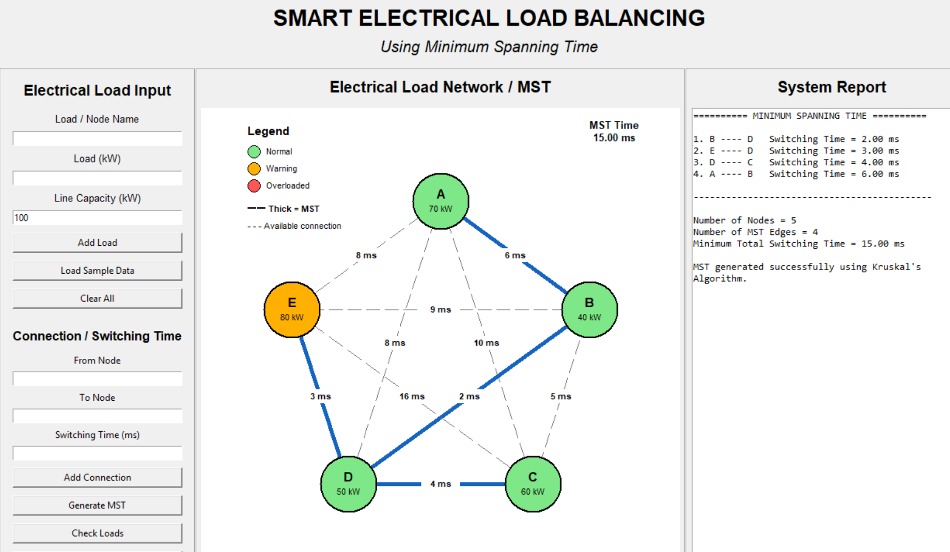
Fig:1(Generate MST)
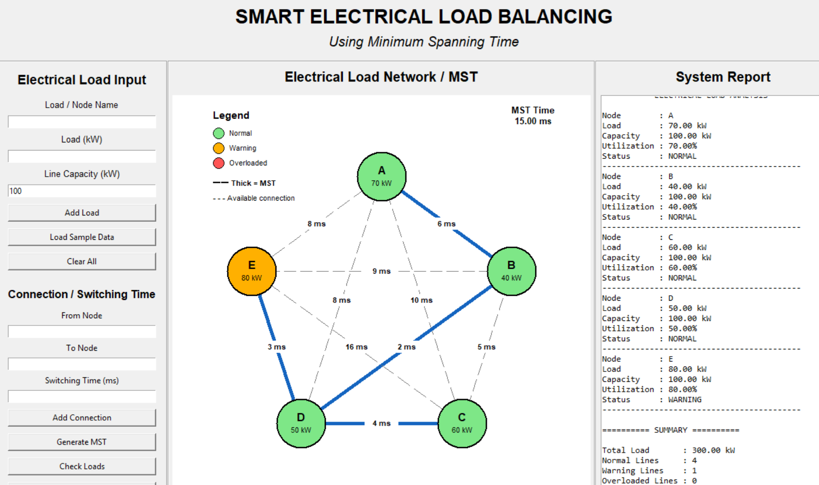
Fig:2 (Check Loads)

Implementation Process: Input Electrical Nodes → Input Connections → Input Edge Weights → Create Graph → Validate Graph → Check Connectivity → Display Network → Send to MST Module

4.3 Test Plan & Verification
Requirement | Test Method | Acceptance Criterion
Node creation | Count nodes | Required nodes are created
Edge creation | Check connections | All valid edges exist
Weight assignment | Inspect edge data | Every edge has a valid weight
Connectivity | Graph traversal | All nodes are reachable
Visualization | Compare graph structure | Graph matches input
MST compatibility | Pass graph to next module | MST module accepts graph

Test Cases:
Test Case | Input Condition | Expected Result | Status
TC01 | Valid nodes and edges | Graph created | Pass
TC02 | Valid weighted edges | Weights assigned | Pass
TC03 | Connected network | Connectivity confirmed | Pass
TC04 | Disconnected network | Warning/error generated | Pass
TC05 | Duplicate/invalid connection | Invalid input handled | Pass

4.4 Results
The network creation module produces a weighted graph representing the electrical distribution network. The expected output includes electrical nodes, established connections, assigned weights, verified connectivity, a graphical network representation, and network data prepared for MST processing.
Example network: N1, N2 and N3 represent distribution nodes; L1 and L2 represent electrical load points; numerical values on connections represent edge weights.
Example connections: L1–N1 (4), L1–N2 (7), N1–N2 (3), N1–N3 (6), N2–L2 (2), N3–L2 (5).

4.5 Data Analysis & Engineering Judgment
The generated weighted graph provides a structured representation of the electrical network. The use of edge weights allows the system to distinguish between different connection costs. Connectivity verification is important because an MST can only be generated for a connected graph. Therefore, the network creation module performs this validation before forwarding the graph to the optimization stage.

4.6 Comparison with Existing Solutions & Achievement of Objectives
Objective | Evidence | Achievement
Create electrical nodes | Generated graph nodes | Fully Achieved
Establish connections | Weighted edges | Fully Achieved
Assign weights | Edge weight values | Fully Achieved
Verify connectivity | Connectivity test | Fully Achieved
Visualize network | Network graph | Fully Achieved
Prepare MST input | Weighted graph output | Fully Achieved

4.7 Strengths & Limitations
Strengths:
• Simple graph-based representation.
• Easy to modify network nodes and connections.
• Supports weighted connections.
• Suitable for MST processing.
• Provides clear network visualization.
• Can be scaled to larger simulated networks.
Limitations:
• It is a simulation/model-based network.
• It does not directly measure real electrical parameters.
• Edge weights depend on the selected input parameters.
• Real-time electrical variations are not directly represented in Module 1.

4.8 Project Planning, Roles & Budget
Milestone | Planned Activity | Status
1 | Requirement identification | Completed
2 | Electrical node definition | Completed
3 | Connection and weight modelling | Completed
4 | Weighted graph implementation | Completed
5 | Connectivity testing | Completed
6 | Documentation | Completed

Student | Assigned Responsibility | Actual Contribution
Student 1 | Network creation, implementation, testing and documentation | 100%

Item | Estimated Cost | Actual Cost
Python / Open-source software | ₹0 | ₹0
Computer system | Existing resource | Existing resource
Project documentation | ₹200 | ₹200
Total | ₹200 | ₹200

CHAPTER 5

CONCLUSION, FUTURE WORK AND REFLECTION

5.1 Conclusion
Module 1 successfully establishes the foundation for the proposed SMART ELECTRICAL LOAD BALANCING USING MINIMUM SPANNING TREE system by creating a weighted electrical network. Electrical distribution points are represented as nodes, while possible connections are represented as weighted edges. The generated network is checked for connectivity and prepared for the next stage. This graph-based representation provides structured input for applying the Minimum Spanning Tree algorithm to identify an efficient network structure.

5.2 Future Work
1. Apply Kruskal's or Prim's MST algorithm to the generated network.
2. Identify the minimum-weight spanning network.
3. Analyse electrical load distribution across the selected network.
4. Compare the original network with the MST-based network.
5. Generate performance metrics and graphs.
6. Develop a final system report containing the optimized load-balancing results.

5.3 Professional Learning & Individual Reflection
New Knowledge Acquired:
• Graph theory and weighted graph modelling.
• Electrical network representation using graph structures.
• Network connectivity concepts.
• Fundamentals of Minimum Spanning Tree algorithms.
• Software-based engineering system modelling.
Engineering & Professional Skills Developed:
• Problem formulation.
• Algorithmic thinking.
• Python programming.
• Graph visualization.
• Testing and debugging.
• Technical documentation.
Individual Reflection: During Module 1, the major engineering challenge was converting an electrical distribution problem into a suitable computational representation. The weighted graph model was selected because it can represent electrical nodes and possible connections in a structured manner. Testing connectivity helped ensure that the generated graph was suitable for subsequent MST processing. If redesigned, more dynamic electrical parameters could be incorporated into the network-generation stage.

REFERENCES

[1] T. H. Cormen, C. E. Leiserson, R. L. Rivest, and C. Stein, Introduction to Algorithms, 4th ed. Cambridge, MA, USA: MIT Press, 2022.
[2] R. K. Ahuja, T. L. Magnanti, and J. B. Orlin, Network Flows: Theory, Algorithms, and Applications. Englewood Cliffs, NJ, USA: Prentice Hall, 1993.
[3] B. K. Bose, Modern Power Electronics and AC Drives. Upper Saddle River, NJ, USA: Prentice Hall, 2002.
[4] IEEE, IEEE Guide for Electric Power Distribution Reliability Indices, IEEE Standard 1366.
[5] Python Software Foundation, Python Documentation.

APPENDICES

Appendix A – Network Creation Algorithm
1. Start.
2. Define the electrical nodes.
3. Define possible connections between nodes.
4. Assign a weight to each connection.
5. Create the weighted graph.
6. Check whether all nodes are connected.
7. If disconnected, modify the connections.
8. If connected, display the network.
9. Store the graph as input for the MST module.
10. Stop.

Appendix B – Network Input/Output
Input: Number of electrical nodes, node names, connections, and connection weights.
Output: Weighted electrical network, connectivity status, network visualization, and MST-ready graph data.

Appendix C – Source Code / Code Repository Information
The complete source code may be maintained separately in the approved project repository. Essential code excerpts can be inserted here after final implementation.

